Research Project Proposal Video Submission Form
Video: 5 minutes max.
You must submit this form via CASC FAS in order for the Selection Committee to review your video submission.

Instructions for posting and submitting your video appear on the second page of this document

Name:

Project Title:

Please paste a link to your YouTube video in the box below:

Remember that your video should include an introduction, methodology, timeline, intended outcomes, and potential impacts.

Please note you will retain data relating to your video submission which you may delete any time after April 1, 2024. Newnham College will not retain a copy of your video submission.
If you prefer not to post a video to YouTube for the purposes of this application, you may instead submit a written statement using the templates provided on https://laidlaw.fund.cam.ac.uk/laidlaw-scholars/apply/

You are asked to provide a link to you ‘unlisted’ video – this means that your video will not be discoverable in searches and only those you provide with a link will be able to view your video. In the context of this application, this mean that only the four reviewers on the Selection Committee and the Laidlaw Coordinator will have access to your video.
Posting an unlisted video:
- Sign into or create your YouTube account.

- Either: Access the YouTube Studio section via Your Videos on the left-hand side of your screen or click on the camcorder icon in the upper right portion of your screen to upload a video.

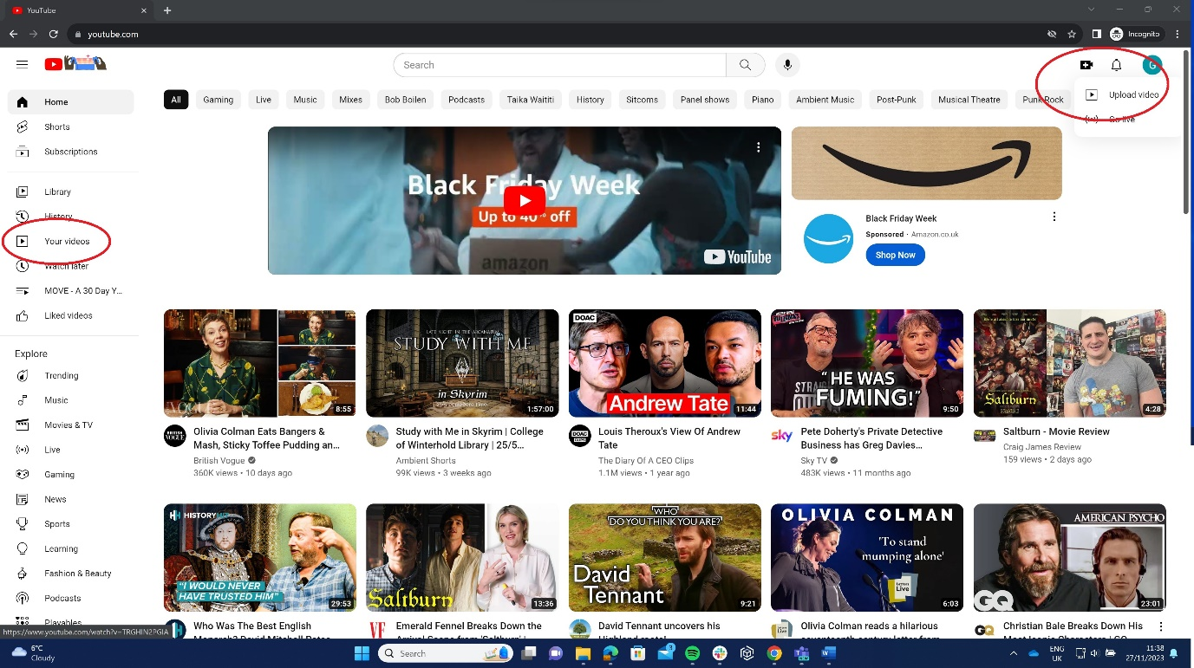

- In the “Details” section, give your video a title using the following format: Firstname Lastname – Research Proposal.

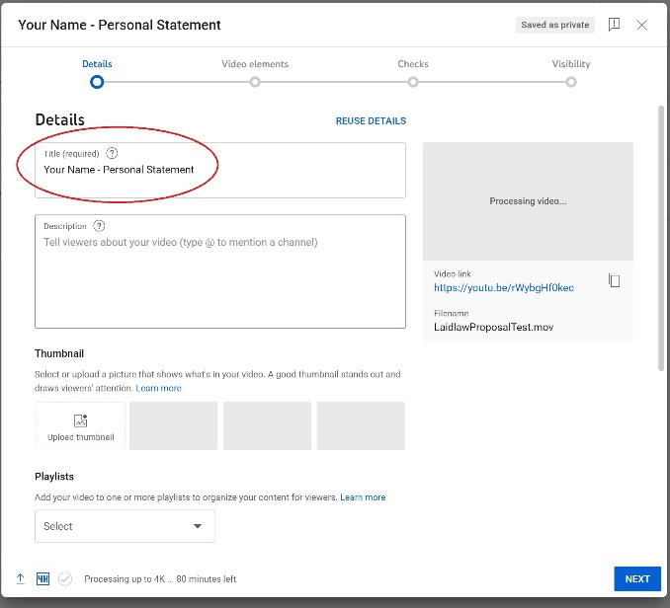

- Under “Visibility,” make sure to select “Unlisted” from the list of options. Do not schedule a date to make your video public.
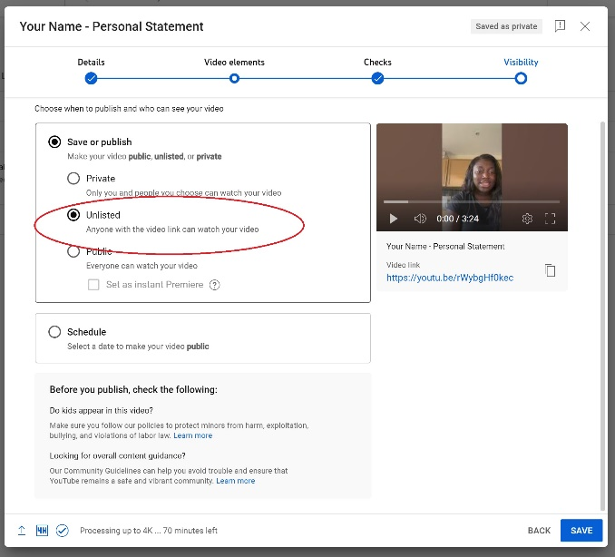

- Copy the video link and paste it into the form above.

- Submit your form to the CASC FAS as either a Word document or a PDF.

- Mark a date in your calendar to delete your video (if you so choose) any time after April 1, 2024.

